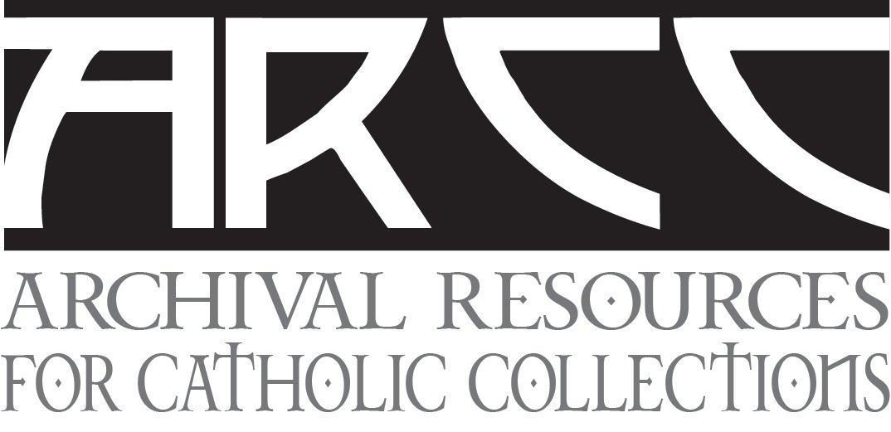

RELEASE DATE:
September 30, 2020

ARCHIVAL RESOURCES FOR CATHOLIC COLLECTIONS (ARCC) ANNOUNCES INAUGURAL SYMPOSIUM SERIES PRESENTATION ON NOVEMBER 12, 2020

CHICAGO, IL, September 28, 2020 — The Archival Resources for Catholic Collections (ARCC) Repository Working Group is proud to announce its inaugural Symposium Series on November 12, 2020. The first symposim will address the various types of repositories serving Catholic religious archives, with a review of solutions available to institutions with diminishing numbers, and practical advice on selecting a repository. Religious leaders, archivists, and scholars across the globe are invited to attend. This online, virtual presentation will be held via Zoom on Thursday, November 12th from 9:00-10:15 p.m. PST/12:00-1:15 p.m. EST/5:00-6:15 p.m. BST.

Presenters for the first ARCC Symposium Series presentation include:
Consolidated Archives: David Miros, Jesuit Archives and Research Center, St. Louis, Missouri;
Diocesan Archives: Tricia Pyne, The Associated Archives of St. Mary’s Seminary and University, Baltimore, Maryland;
University Archives: Nadia Nasr, Archives & Special Collections Department, University Library, Santa Clara University, California;
Public Repository: Carey Pallister, Sisters of St. Ann, Royal BC Museum and Archives, Victoria, Canada;
and Collaborative Archives: Malachy McCarthy, Claretian Missionaries Archives, Chicago, Illinois.

Attendees are asked to pre-register for this free ARCC Symposium Series presentation no later than November 5, 2020 at https://www.surveymonkey.com/r/Z7DZR2Z.

The purpose of the ARCC Repository Working Group is to develop guidance and best practices for collaborations between religious communities and/or academic institutions. Areas of consideration include defining responsibilities for shared or deposited collections, assistance with financial support, descriptive standards, and privacy and access concerns. The ARCC welcomes interested parties to become active in the new organization. For more information regarding the Symposium Series presentation or to join the ARCC Google group, please visit www.archivalrcc.org

Contact: Malachy McCarthy, Claretian Archives, archivalrcc@gmail.com
###

