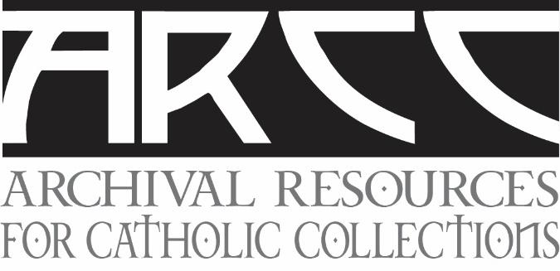
Repository Working Group
Legal Issues in Religious Archive Practice
Wednesday, June 2, 2021
9 a.m. PDT 12 Noon EDT 5 p.m. GMT
With completion of many religious communities on the horizon, the legal issues become more complex as the community transfers its archives to a third-party repository. There are questions including: 1) how will the historical charism and legacy be respected and preserved? 2) does the permanent repository have a clear understanding of the charism of the community? 3) is the repository committed to arrange and describe collections? and 4) how does an institute move from a permanent loan to a full deposit?
Establishing a process by which disagreements between the donor community and repository institution can be resolved is essential. Establishing terms if either party wants to withdraw from the arrangement is important. The three presenters will address the legal issues from their unique perspective.
Sr. Ginger Downey, OLVM, is a current member of the Leadership Team for the Congregation of Our Lady of Victory Missionary Sisters, commonly known as Victory Noll sisters. She is in her ninth year on the Leadership Team and has serves as a liaison with the archives. She is also currently working to create a collaborative archive and research center with other congregations of religious women in the Midwest.
Christopher J. Fusco, JCL, Esq. is a tribunal judge and the associate general counsel for the Diocese of Metuchen in New Jersey, as well as the associate director for civil law at the Resource Center for Religious Institutes in Silver Spring, Maryland. He received his master's degree in theology as well as a licentiate degree in canon law from The Catholic University of Louvain in Belgium. He earned his law degree from The City University of New York School of Law. He is admitted in New York and New Jersey.
Margaret Sanche serves as diocesan archivist/historian of the Roman Catholic Diocese of Saskatoon, Saskatchewan, Canada and, in this role, also cares for the archives of the Oblates of Mary Immaculate (former St. Mary’s Province) and seven congregations of women religious whose members have served in the Saskatoon diocese over many years. The history of this collaboration and the specific canonical details of the agreements worked out between the Diocese of Saskatoon and the religious congregations for the care of their records over the long term will be outlined in her presentation.
To register for this seminar, please click this link to register:
https://www.surveymonkey.com/r/XJGVT8G
Registration will close on May 30, 2021.
Thank you to Santa Clara University for generously hosting this event.

